**MyJobApplicationExe**

A Freeware Tool

by

Muhammet ATALAY

<https://github.com/TheMaty>

Contents

Introduction 3

Application Overview 4

User Guide 4

FollowUp (FollowUp.exe) 4

MyJobApplication 5

Create Job Application 5

Create Activity 7

Follow Up 8

Technical 10

Directory structure of data repository 11

Table structure (XML File Structure) 12

Development 13

# Introduction

MyJobApplicationExe is free tool who wants to track Job Applications and Contracts in order to find a position or opportunity immediately by organizing

Clients – Agents – Head-hunters – Job-Opportunity Advertisement – Activities

It is a Windows Form application top of .NET Framework 4.8.

Application does not use any databases but only windows file structure repository

Application deliveries Main form which defines all functionalities and capabilities, monitoring that displays Follow-ups as a reminder.

You can create Job Application and related activities to track position/opportunity quickly through couple shortcuts and tips.

# Application Overview

You can create 4 types of entities to meet finding a contract/position:

* Application: Job advertisement.
* Activity: contact with advertiser.
* Company: an organization which opens advertisement.
* Contact: who should be kept in touch.

## User Guide

There are 2 forms come with the application

### FollowUp (FollowUp.exe)

It displays only FollowUp activities for closely tracking the application

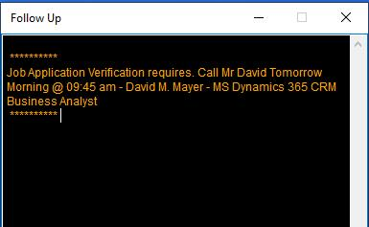

Figure 1: Main screen of FollowUp

Tips: It is highly recommended to add it to the Windows Startup (search internet for instruction)

### MyJobApplication

It is main forms of the application and consists of 3 sections:

1. “Tree View” lists open or closed applications and FollowUp type activities. Meanwhile it groups job applications and activities into advertiser, company, regarding, status (open, closed)
2. “Search” finds given text in the any applications and activities in repository. It is context search and help the user to reach any records quickly.

Search has auto-complete feature thus, once you type a letter, Application displays possible values. It is valid for multiple word entry such as if you have couple search criterias, just type characters, System automatically finds proper values then when you click “space” in your keyboard another hint will occur finally click “Search” to see all matching records.

1. Display application or activity is designed to display selected record details. It can be either job application or activities.

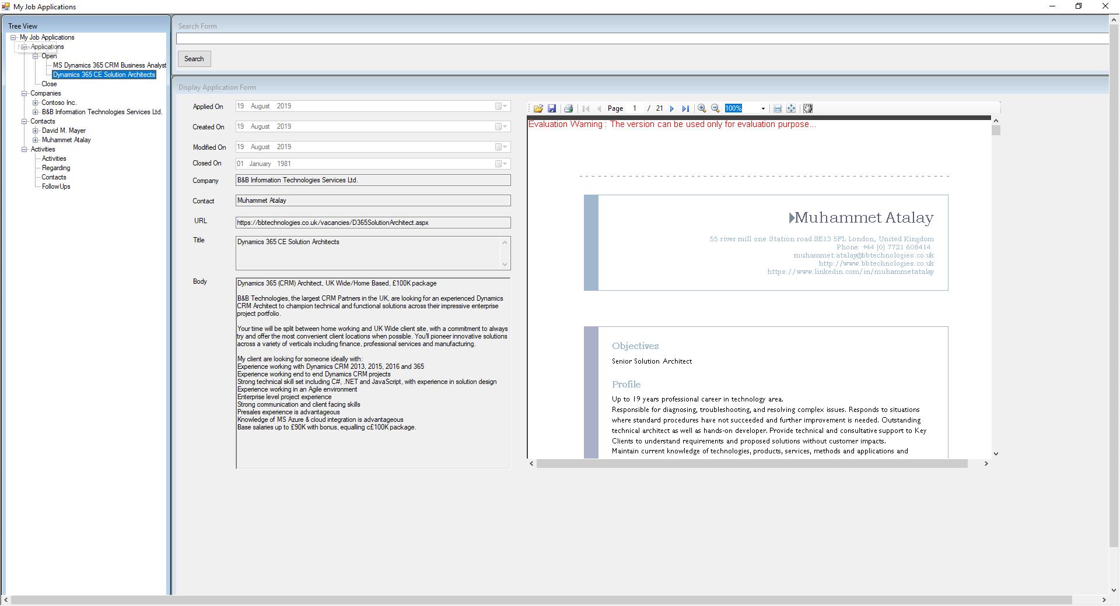

Figure 2: Main form of My Job Application

### Create Job Application

Follow the steps to create new record:

1. Open application
2. Expand “My Job Application” from the tree then select “Applications” leaf.
3. Right-Click to mouse to the selected node and select “Apply for a Job”

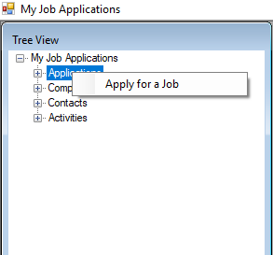

Figure 3: Job Application Creation

1. A form will display in the right section of the window.

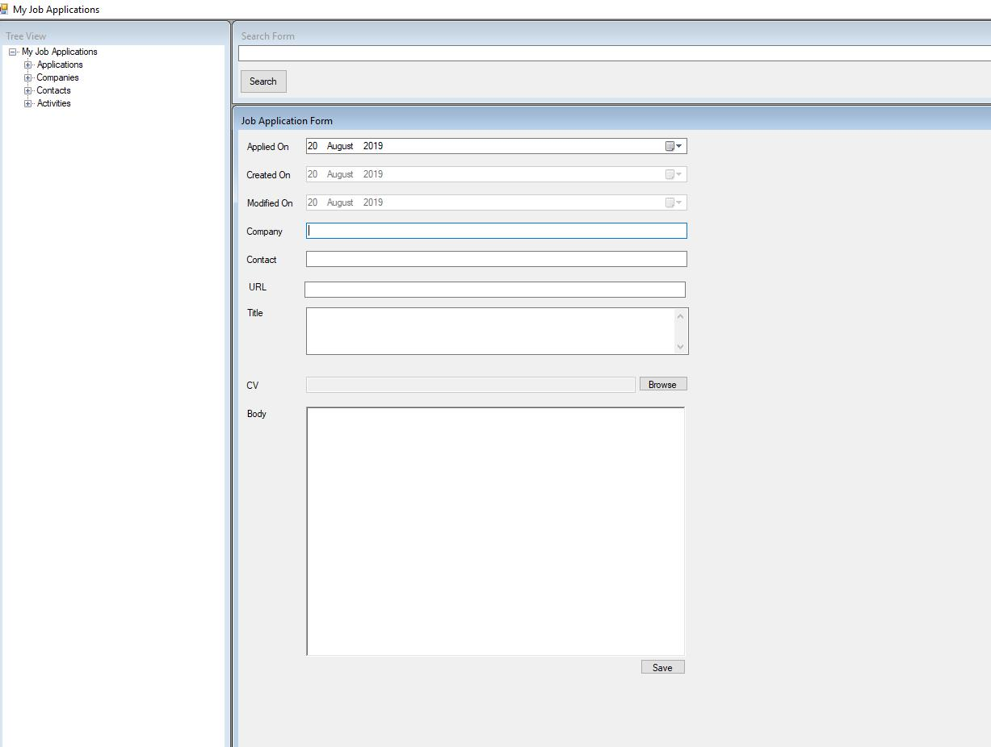

Figure 4: Job Application Form

1. Copy and paste advertisement to the URL first, if the job advertisement is published in internet. System automatically fetch the body. You can use it as a shortcuts of filling rest of the items.
2. Add CV that you are used for the application through “Browse”. There may have couple resumes based on role(s) that is applying.
3. Fill all items respectively then click Save.  
   Note: Company and Contact text area have auto-fill feature so when you type any char, system searches against any previous record for recommendation.

### Create Activity

Follow the below steps to create activity, it can be related with job application or any contacts (advertisers):

1. Open My Job Application
2. Expand root of the Tree view in the left
3. Select Activities node
4. Right-click to the selected area and click “Add Activity”

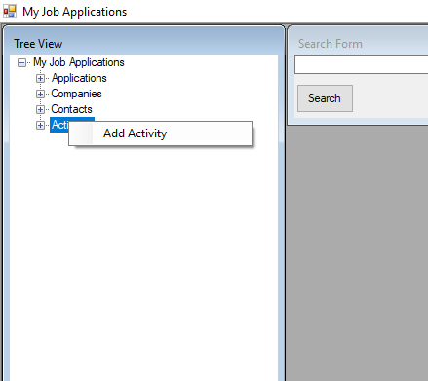

Figure 5: Add Activity

1. Activity Form will display then select type of activity. It is configurable so you can add new type (Ref: Technical section)
2. Fill fields then click save button.   
   Regarding and contact sections are auto-completed.  
   for example:  
   if the activity is about any existing Job Applications, just type few characters of the Job application then select from the list.

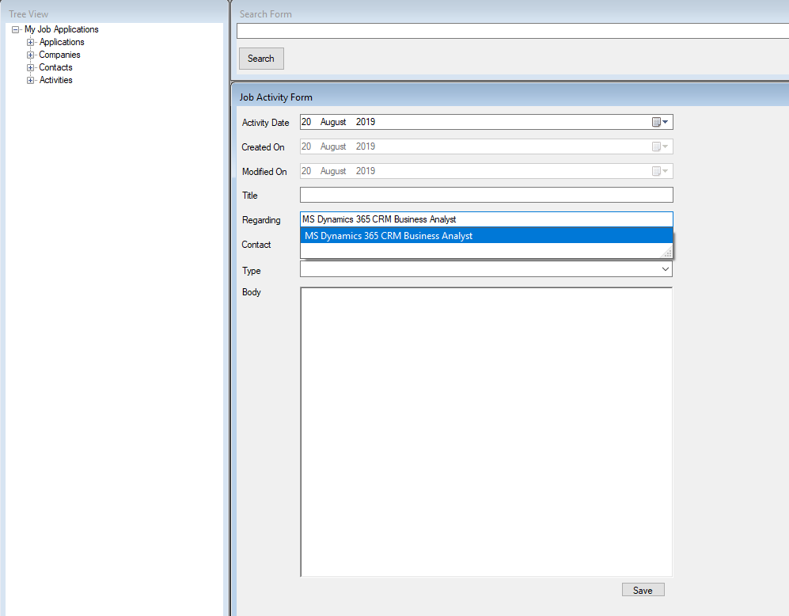

Figure 6: Activity Form

### Follow Up

If you want to keep closer to any applications you can use the feature. Just select the “Open” Job Application from the tree view then click Job Application where you want to pin FollowUp after that right click to the selected node finally click “Create FollowUps” from the menu.

FollowUp is a specific type of Activities so form is exactly same with activity.

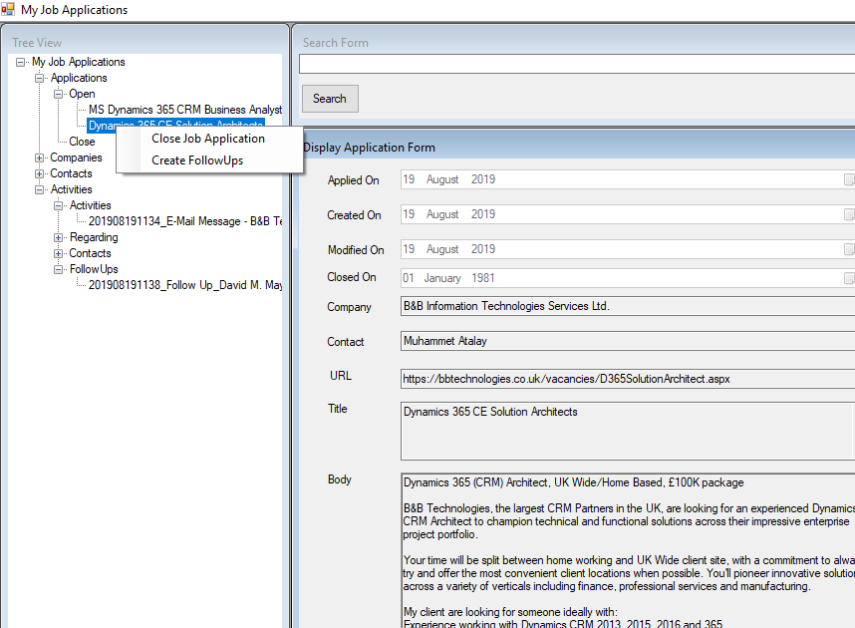

Figure 7: Create FollowUps

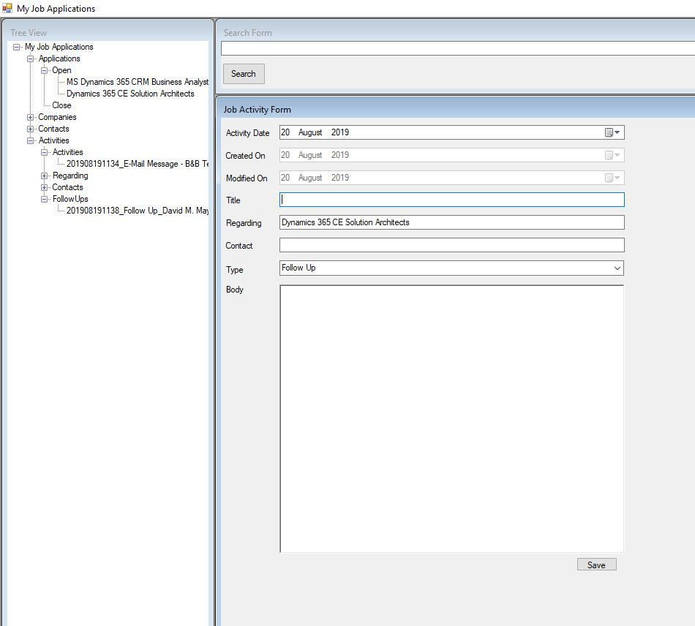

Figure 8: FollowUp - specific- type of Activity

## Technical

It is developed with Visual Studio 2019 Community Edition.

As there is no database, data are stored under windows operating system in XML format so each XML files describes rows as well as folder is Database. Name of the XML file points out Indexes.

Database file can be defined from DBFile key under appSettings tag in config file (MyJobApplication.exe.xml)

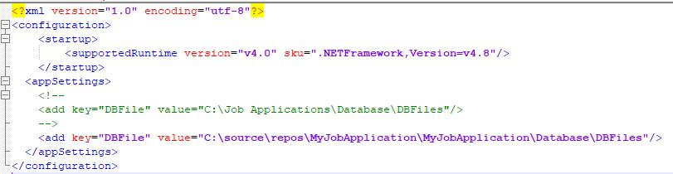

Figure 9: AppConfig of My Job Application

### Directory structure of data repository

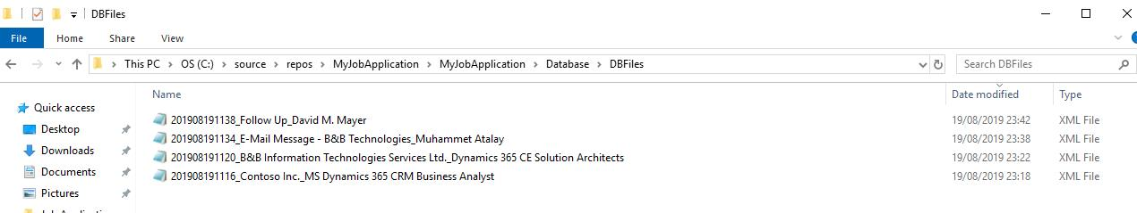

Figure 10: Repository Structure

According to screen above, each xml file addresses DataRow in traditional ER Database.

### Table structure (XML File Structure)

There are 2 types of table (Namely Database Tables):

* Job Application

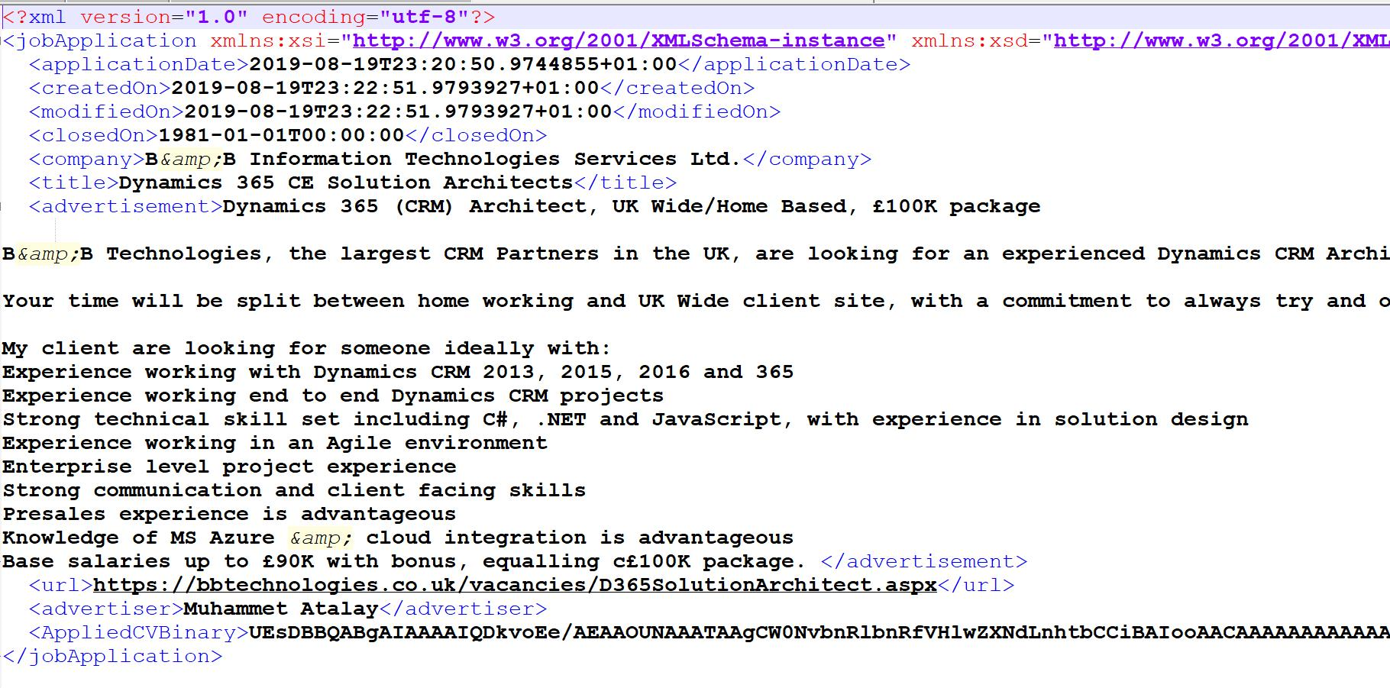

Figure 11: JobApplication Table Structure

* Activity

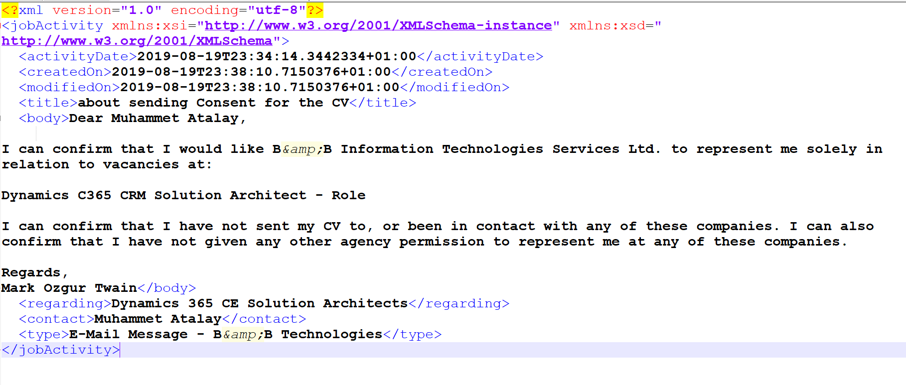

Figure 12: Activity Table Structure

Each tag represents columns in the classic database whereas each XML file means rows and name of the XML files pretend Index.

### Development

3 projects come with the solution:

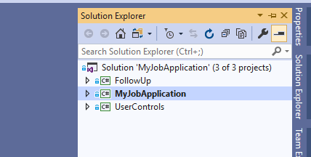

Figure 13: Solution Structure in Visual Studio 2019 Community Edition

* FollowUp is a monitoring and tracking of the Job Application. It does not print maximize button on the windows control and avoid closing the form due to design. It can be closed from Task Manager, but not recommended since it is Task Monitor for the users.

FollowUp checks repository periodically if there is any type of “Follow Up” activities but not “closed” (file name is important in the app and contains all keys and remarks.)



Figure 14: Folluw-Up type repository sample

Period is configurable through Follow Up.exe.config file

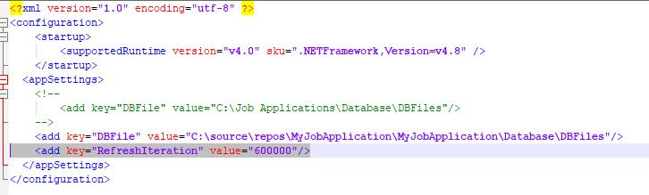

Figure 15: Configuring FollowUp monitoring refresh time in millisecond

MyJobApplication is main form of the tool. It is MDI Container that host Windows forms. AppConfig (MyJobApplication.exe.config) can be used for configuration of repository path and activity types (Add comma separated value for new activity type).

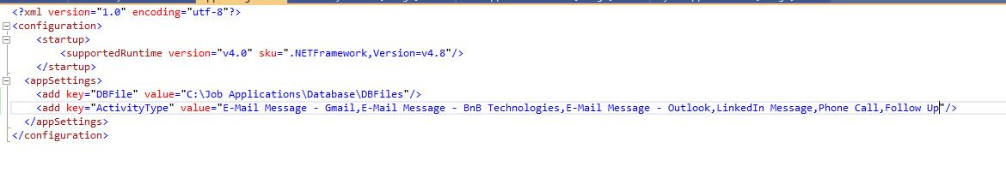

Figure 16: Application Configuration file of Main form

* UserControls: Deprecated.